Chromebook (see RLS for details)
Inexpensive plug-in ear buds– to be kept at school
NO WIRELESS EARBUDS OR HEADPHONES, PLEASE
NIV or ESV Bible
Student Planner (Recommended)
PE Uniform (purchased at RLS)
2 combination locks (purchased at RLS)
2 dozen #2 Pencils (wood or mechanical) Package of 2 pink erasers
Pens: Black/Blue and Red
3 pkgs. Wide-ruled notebook paper
Plastic ruler (in/cm)
1 pencil case or bag
1 set of markers
1 set of colored pencils
1 – 4 pack of dry-erase markers
4 glue sticks

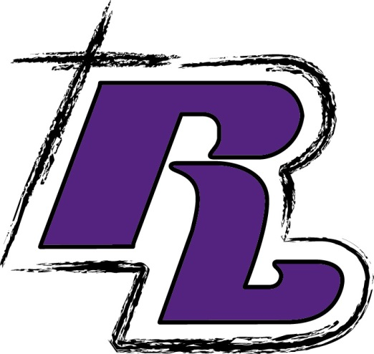
Subject/Teacher Supplies
English
1 subject spiral notebook (red)
1 – ½ in. 3 ring binder (red)
2 – 2- pocket folders w/NO PRONGS (red)
– 1 for Grammar, 1 for Literature
1 pkg. colored index cards (must have 4 different colors)
Jumbo book cover (red)
Novels- The Tenth Mistake of Hank Hooperman by Gennifer Choldenko; Others- TBD

Art/Band/Choir- TBD

Drama/Theater
1- 2 pocket folder

Jr. High Concert Orchestra
3 ring binder
Plastic sheet inserts
Essential Elements Book 2

Math
1 – 3 subject spiral notebook (green)
1 – 2- pocket folder (green)
Scientific calculator
Jumbo book cover (green)

Literature and Informational Texts
1 – 2- pocket folder (your choice)
- 1- subject spiral notebook

Science
1 – 3 subject notebook (blue)
1 – 2- pocket folder w/ NO PRONGS (blue)
1 pkg. index cards
1 – Computer mouse
- Composition Notebook

Social Studies
1 – 2- pocket folders (purple)
1 pkg. index cards
Jumbo book cover (purple)

Religion
1 – 1- subject spiral notebook (yellow)
1 – 2- pocket folder (yellow)
Rockford Lutheran
6th
Grade School Supply
List
~
2026-2027
General Supplies (required for more than one class)

