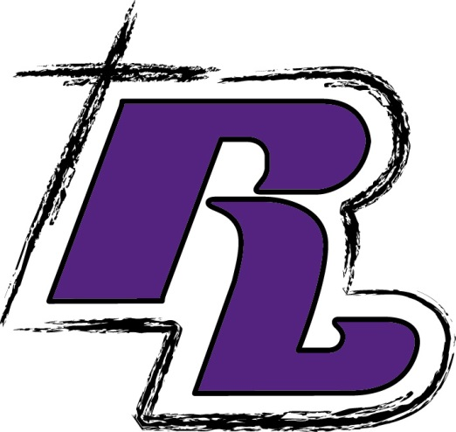
Chromebook (see RLS for details)
Inexpensive plug-in ear buds – to be kept at school
NO WIRELESS EARBUDS OR HEADPHONES, PLEASE
NIV or ESV Bible
Student Planner (Recommended)
PE Uniform (purchased at RLS)
2 combination locks (purchased at RLS)
2 dozen #2 Pencils (wood or mechanical)
3- pkgs. Wide-ruled notebook paper
Package of 2 pink erasers
Pens: Black/Blue and Red
Plastic ruler (in/cm)
1 pencil case or bag
1 set of markers
1 set of colored pencils
1 – 4 pack of dry-erase markers
4 glue sticks
Subject/Teacher Supplies
English
1 – 2- pocket folder w/ NO PRONGS (red)
2 – 1 subject spiral notebooks (red)
1 pkg. of index cards
Novel – The Tenth Mistake of Hank Hooperman
By Gennifer Choldenko

Jr. High Concert Orchestra
3 ring binder
Plastic sheet inserts
Essential Elements Book 2

Religion
1 subject spiral notebook (yellow)
1 – 2 pocket folder (yellow)

Band/Choir- TBD

Drama/Theater
1- 2- pocket folder

Math
3 subject spiral notebook (green)
1 – 2- pocket folder (green)
Scientific calculator
Jumbo book cover (green)

Literature and Informational Texts
1 – 2- pocket plastic folder
1- composition notebook
Novels- TBD

Science
3 subject spiral notebook (blue)
1 – 2- pocket folder w/ NO PRONGS (blue) Jumbo book cover (blue)
1 pkg. white index cards
1- Composition Notebook

Social Studies
1 pkg. wide-ruled notebook paper
1 – 2- pocket folder (purple)
1 pkg. 3x5 index cards

Rockford Lutheran
7th
Grade School Supply
List
~
2026-2027
General Supplies (required for more than one class)

