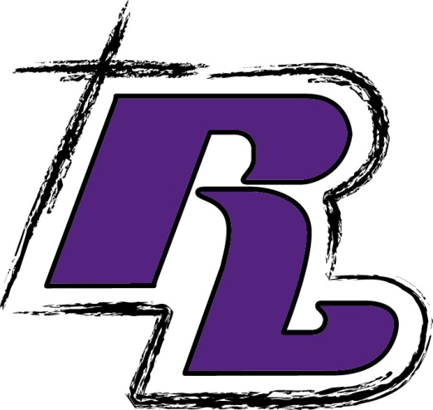

**English**

1 – 1 in. 3 ring binder

1 subject spiral notebook

1 pkg. of index cards

Jumbo book cover

Novels: Honors English- *The Outsiders* by Hinton, *A Christmas Carol* by Dickens, *Among the Hidden* by Haddix

On Track English: *The Outsiders* by Hinton

**French/Spanish**

1- 3 subject spiral notebook

1- two pocket folder

**Health**

1 – Two pocket folder

**Art- TBD**

**Choir- TBD**

**Band- TBD**

**Drama/Theater**

1- notebook

1- two-pocket folder

**Creative Writing/Journalism**

Rockford Lutheran

8th

Grade School Supply

List

~

2025-2026

General Supplies (required for more than one class)

Chromebook (see RLS for details)

Inexpensive plug-in ear buds – to be kept at school

NO WIRELESS EARBUDS OR HEADPHONES, PLEASE

NIV Bible

Student Planner (Recommended)

PE Uniform (purchased at RLS)

2 combination locks (purchased at RLS)

2 dozen #2 Pencils (wood or mechanical) Package of 2 pink erasers

Pens: Black/Blue and Red

Plastic ruler (in/cm)

1 pencil case or bag

1 set of markers

1 set of colored pencils

1 – 4 pack of dry-erase markers – fine tip

Calculator – Texas Instrument Scientific Calculator (recommended)

Subject/Teacher Supplies

**Jr. High Concert Orchestra**

3 ring binder

Plastic sheet inserts

*Essential Elements* Book 2

**Math**

3 subject spiral notebook (green)

1 – Two pocket folder (green)

Scientific calculator

Jumbo book cover

**Science – Earth and Physical** Binder/Folder for notes and handouts Spiral notebook

Safety goggles

**Social Studies – U.S. History**

1 - 1.5 in. 3 ring binder

Jumbo book cover

**Religion**

1 subject spiral notebook

1 – Two pocket folder